Savoy metrics 🡪 summary

* In past two/three decades, there seems to be a trend upwards for lexical diversity and lexical density (more range in lexical words, and a growing majority of lexical words relative to functional/more descriptive).
* Mean sentence length: trend downwards. Corroborates argument of less complex recently
* Big words: more big words in first few decades than recent few;

Big dip 85 onwards

however, a spike in 1999 … (mentions commonwealth and millennium a few times - could be part of reason for spike)… could look at specific words (adjectives and verbs)

more lexical and still reduction in big words. Longer words are more often lexical (is this true?)

* Lexical diversity

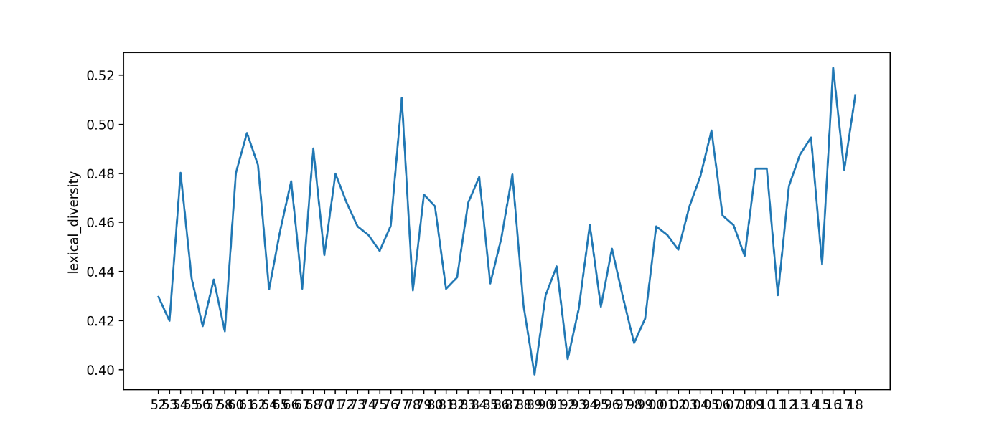

* Mean sentence length

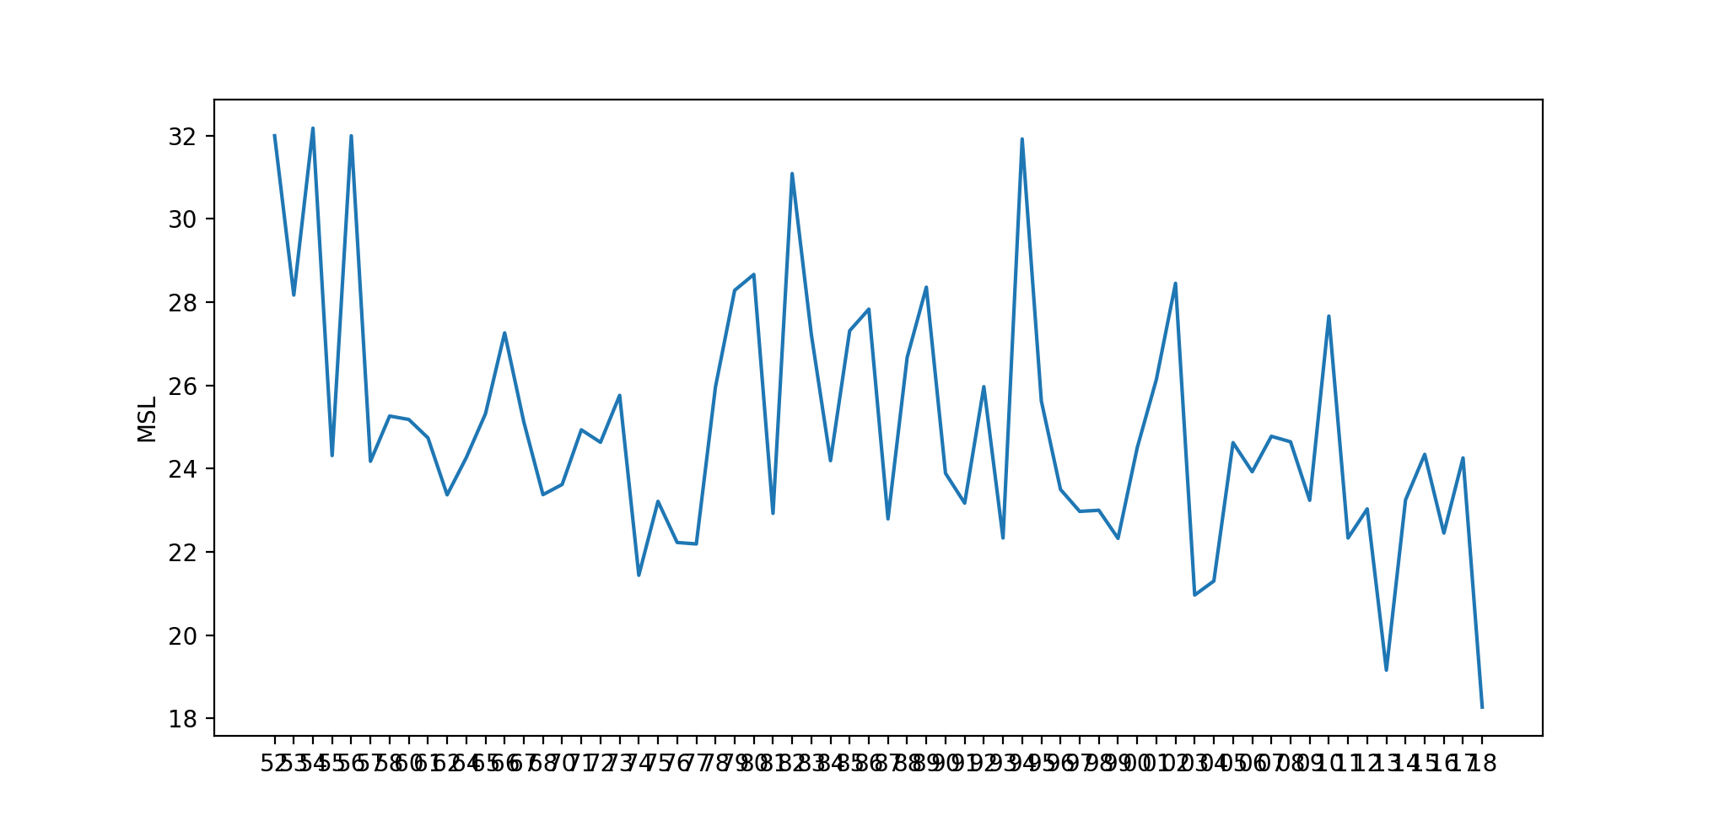

* 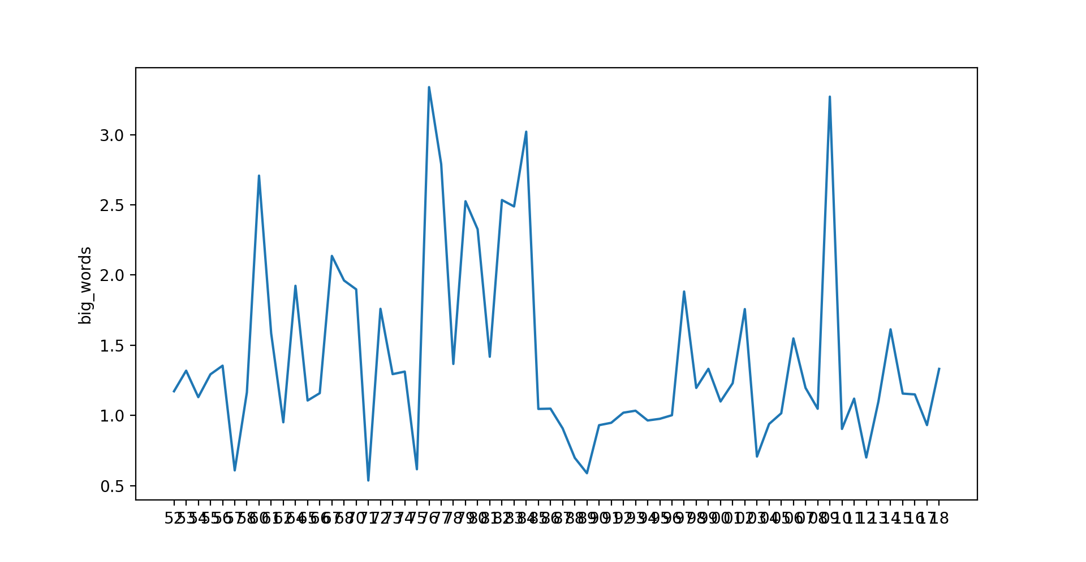Big words
* Lexical density

